**NODE JS - SCALAR**

1. **Introduction :**

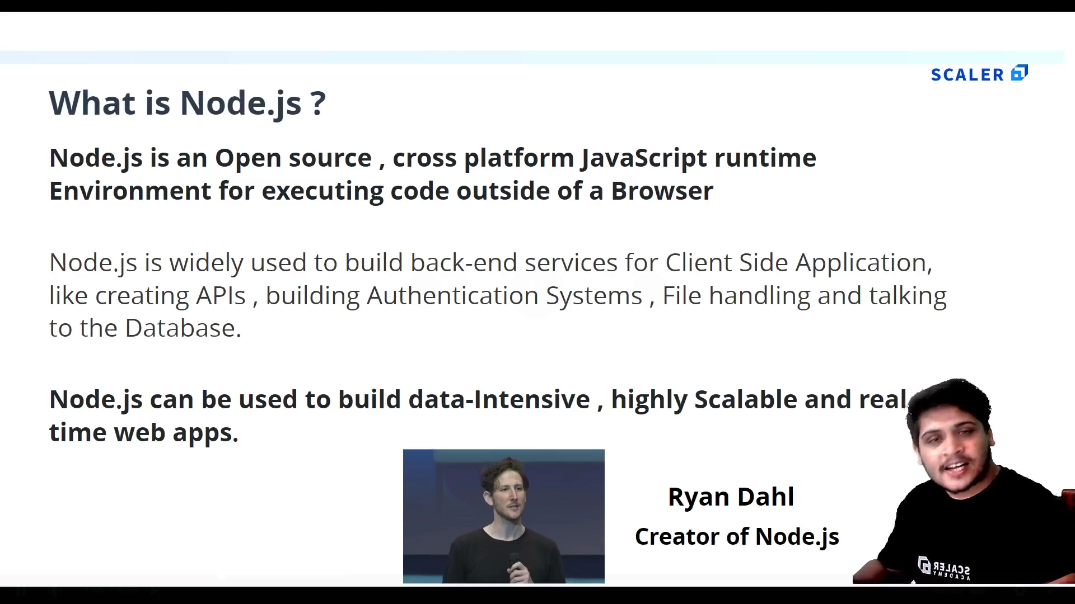

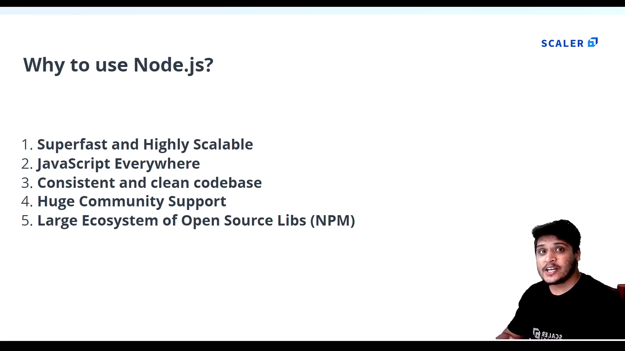

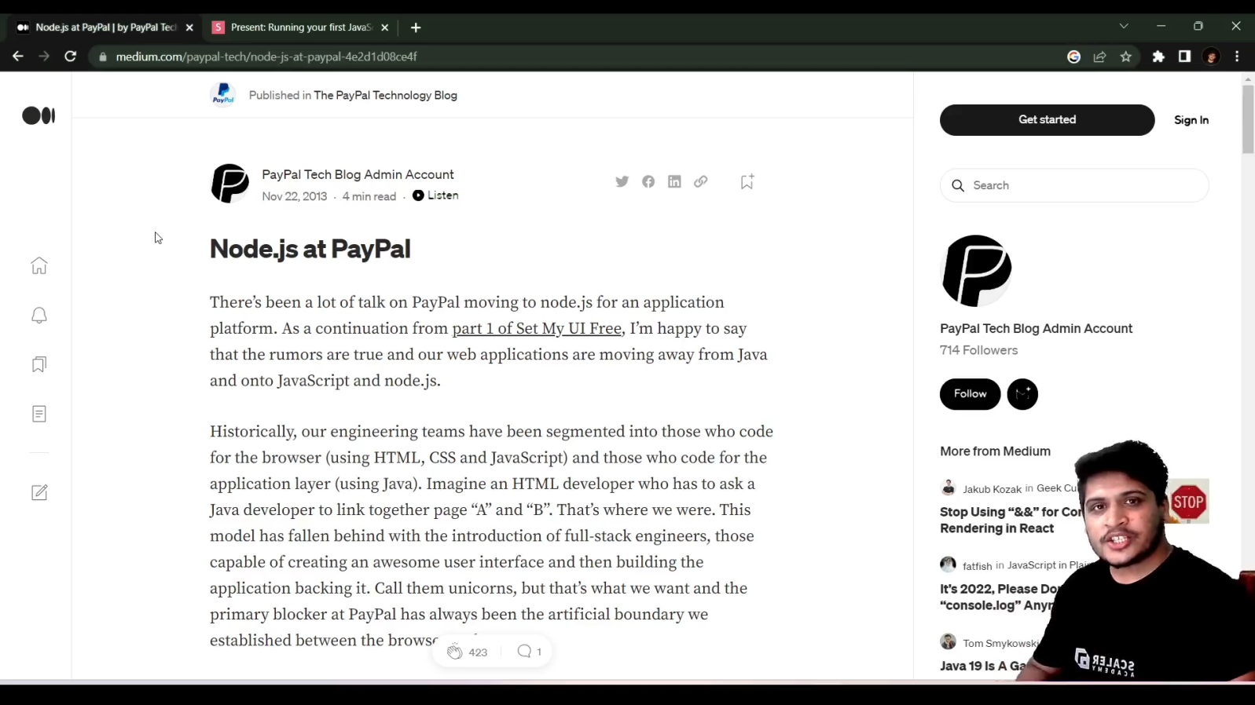

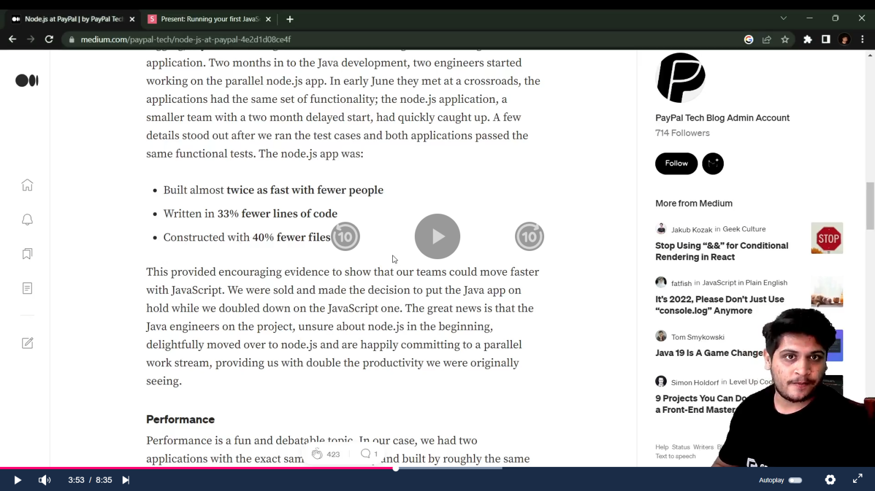

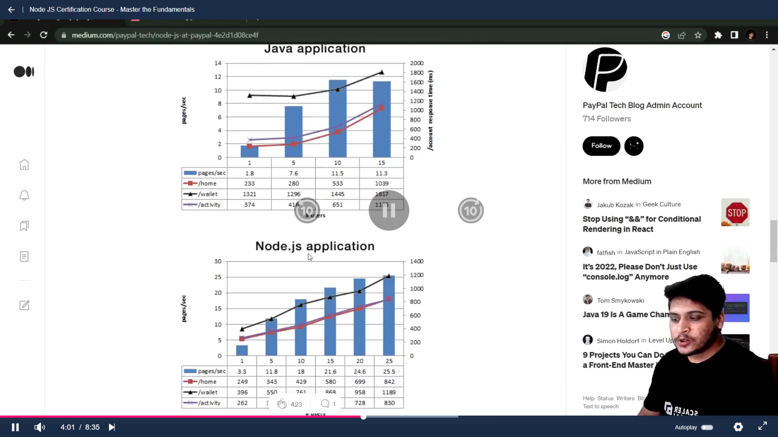

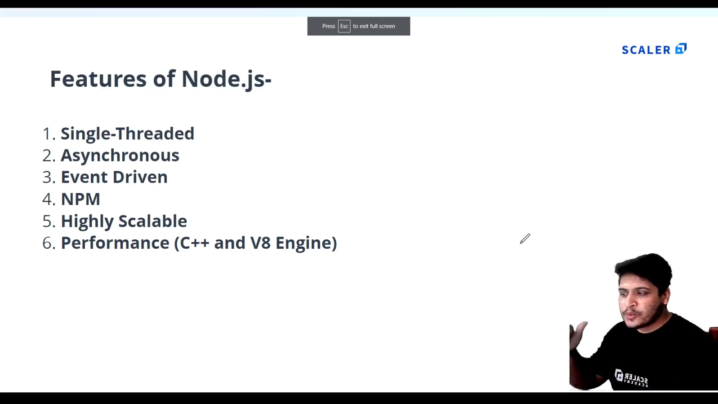

1. **Install Node.js and VScode.**
2. **First Node program :**
   1. **Create a js file with a function:p1_test.js**

console.log('Hello World');

function sayHello(){

    console.log('Hello from anshad');

}

sayHello();

* 1. **To Execute type “node name_of_program.js” : node p1_test.js**

1. **There is no “window” object in Node js instead we have “global” object.**

console.log(global);

PS E:\MCA\COURSES\NODE JS\nodejs_certification@scalar> node p1_test.js

<ref *1> Object [global] {

  global: [Circular *1],

  clearImmediate: [Function: clearImmediate],

  setImmediate: [Function: setImmediate] {

    [Symbol(nodejs.util.promisify.custom)]: [Getter]

  },

  clearInterval: [Function: clearInterval],

  clearTimeout: [Function: clearTimeout],

  setInterval: [Function: setInterval],

  setTimeout: [Function: setTimeout] {

    [Symbol(nodejs.util.promisify.custom)]: [Getter]

  },

  queueMicrotask: [Function: queueMicrotask],

  structuredClone: [Function: structuredClone],

  atob: [Getter/Setter],

  btoa: [Getter/Setter],

  performance: [Getter/Setter],

  fetch: [Function: value],

  crypto: [Getter]

}

1. **The “global” Object :**
2. **A**
3. **A**
4. **a**